PREPARING FOR EUROSCOLA DAY

The object of the opening meeting is to enable the schools to introduce themselves and get to know each other. One of your students, acting as spokesperson, will be called upon to give a one-minute presentation of the class, speaking not in his or her mother tongue, but in one of the official languages used by the institutions. The discussions at the plenary sitting and in the working groups and committees will be conducted mainly in English and French.

The students will be divided into six working groups of equal size. Each group will consider one of the topics below. No student may belong to more than one group.

Group | ‘Environment and renewable energies’ (trapezium)  How can we help bring about a change in behaviour? How can we encourage sustainable development?
Group | ‘Freedom of information and active citizenship’(arrow)  Do the media contribute to the democratic debate? What opportunities and potential pitfalls does today’s development of ICT have in store?
Group | ‘2013 – European Year of Citizens’ (triangle)  Myth or reality? How can we reconcile diverse cultures and regional, national and European identities?
Group | ‘Europe’s future’ (lozenge)  How do you think Europe could be brought closer into line with your ideals?
Group | ‘Agricultural policy’ (circle)  From the farmer to the consumer, what agricultural and food policy should we choose? How can we reconcile food security and sustainable agriculture with the viability of the sector?
Group | ‘Migration and integration’ (square)  How can we maintain balance in society? What are the basic rules that must be respected? How can we manage migration flows in the Euro-Mediterranean region?
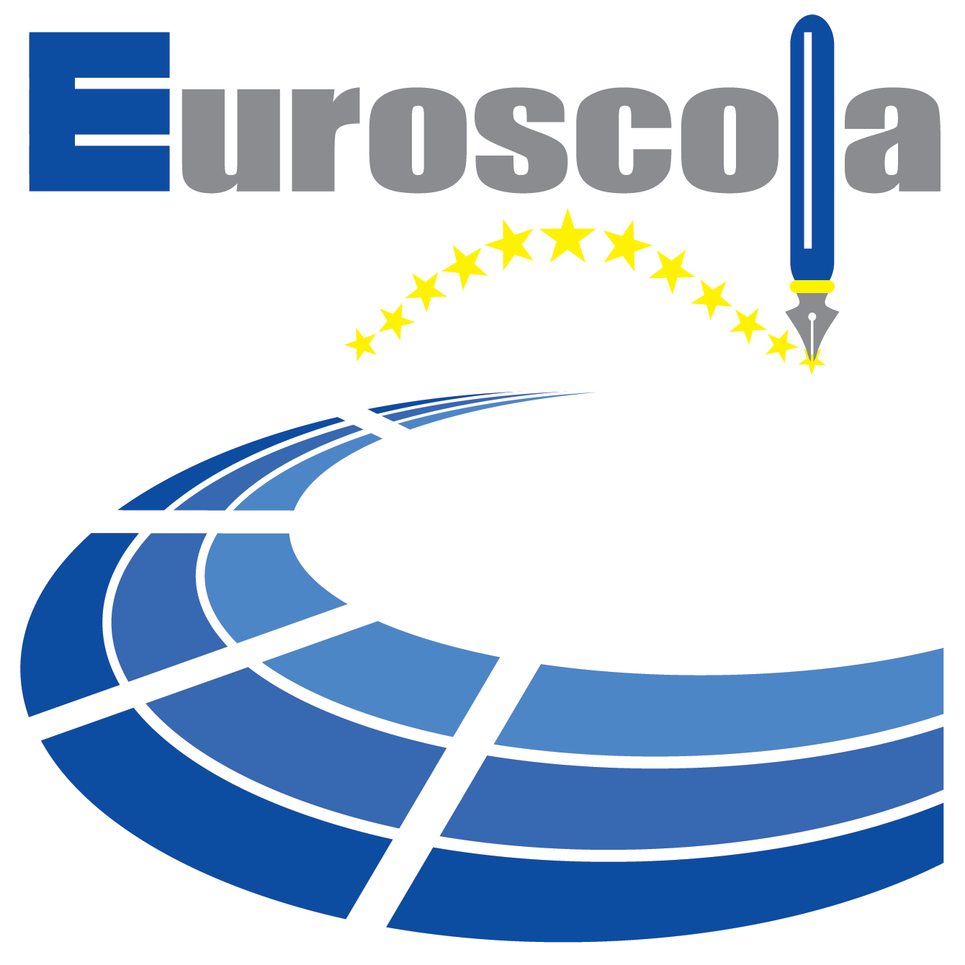
http://www.europarl.europa.eu/euroscola/view/en/how_to_prepare/classroom.html

